Consider the following constraint graph to apply your algorithm.

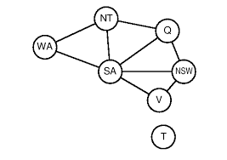

Instructions:

1. You have to submit source code and output screenshot
2. Time: 23rd November 2021 (11:59 PM)